Course 36 ---- DS1302 and LCD1602

**The purpose of the experiment:**

In this course we mainly study the use of DS1302 module and LCD1602 module.

The actual object is shown below.

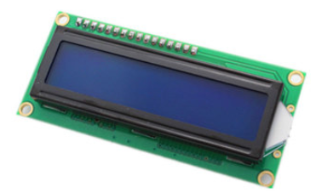 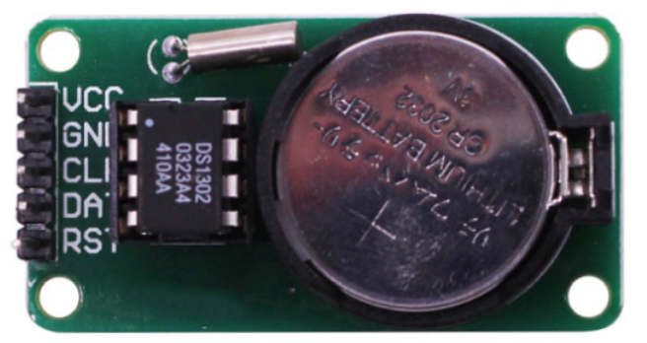

**List of components required for the experiment:**

Arduino UNO board *1

USB cable *1

DS1302 module *1

LCD1602 module *1

Adjustable resistor *1

Breadboard *1

Dupont line *1 bunch

**Actual object connection diagram：**

We need to connect the circuit as shown in the figure below.

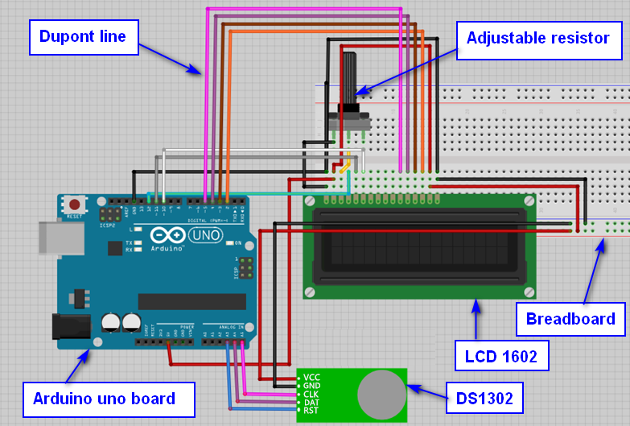

**Experimental code analysis:**

/**

* @par Copyright (C): 2010-2019, Shenzhen Yahboom Tech

* @file 36.DS1302 and LCD1602

* @author liusen

* @version V1.0

* @date 2017.11.14

* @brief Arduino Sensor Kit

* @details Arduino connect to DS1302

Serial input: 2017,11,10,11,59,20,6

Note: 1-7 Sunday - Saturday

* @par History

*

*/

#include <stdio.h>

#include <string.h>

#include <DS1302.h>

#include <LiquidCrystal.h>

const uint8_t CE_PIN = A3;

const uint8_t IO_PIN = A4;

const uint8_t SCLK_PIN = A5;

char day[10];

int numdata[7] ={0};

DS1302 rtc(CE_PIN, IO_PIN, SCLK_PIN);

LiquidCrystal lcd(12,11,10,5,4,3,2);

/**

* Function print_time

* @author liusen

* @date 2017.11.14

* @brief Print time to serial port

* @param[in] void

* @retval void

* @par History

*/

void print_time()

{

char buf[30];

Time t = rtc.time();

memset(day, 0, sizeof(day));

switch (t.day)

{

case 1: strcpy(day, "Sunday"); break;

case 2: strcpy(day, "Monday"); break;

case 3: strcpy(day, "Tuesday"); break;

case 4: strcpy(day, "Wednesday"); break;

case 5: strcpy(day, "Thursday"); break;

case 6: strcpy(day, "Friday"); break;

case 7: strcpy(day, "Saturday"); break;

}

snprintf(buf, sizeof(buf), "%s %04d-%02d-%02d %02d:%02d:%02d", day, t.yr, t.mon, t.date, t.hr, t.min, t.sec);

Serial.println(buf);

}

/**

* Function print_time

* @author liusen

* @date 2017.11.14

* @brief LCD1602 display

* @param[in] void

* @retval void

* @par History

*/

void display_time()

{

char temp[30] = {0};

Time t = rtc.time();

char week[5];

switch (t.day)

{

case 1: strcpy(week , "Sun"); break;

case 2: strcpy(week ,"Mon"); break;

case 3: strcpy(week ,"Tues"); break;

case 4: strcpy(week ,"Wed"); break;

case 5: strcpy(week ,"Thur"); break;

case 6: strcpy(week ,"Fri"); break;

case 7: strcpy(week ,"Sat"); break;

}

snprintf(temp, sizeof(temp), "%02d-%02d-%02d %s", t.yr, t.mon, t.date, week); //t.yr, t.mon, t.date, t.hr, t.min, t.sec ,week

lcd.setCursor(1,0);

lcd.print(temp);

snprintf(temp, sizeof(temp), "%02d:%02d:%02d", t.hr, t.min, t.sec );

lcd.setCursor(4,1);

lcd.print(temp);

}

/**

* Function setup

* @author liusen

* @date 2017.11.14

* @brief Initialization configure

* @param[in] void

* @retval void

* @par History

*/

void setup()

{

Serial.begin(9600); //The baud rate is 9600

rtc.write_protect(false); //turn off write protection

rtc.halt(false);

lcd.begin(16, 2); //Define 1602 liquid crystal display range is 2 rows and 16 columns of characters

lcd.home(); //Move the cursor back to the upper left corner, that is, output from the beginning

lcd.clear();

Time t(2017, 11, 25, 18, 39, 25, 7);

rtc.time(t);

rtc.write_protect(true); // turn on write protection

}

/**

* Function loop

* @author liusen

* @date 2017.11.14

* @brief Print and display the current time

* @param[in] void

* @retval void

* @par History

*/

void loop()

{

print_time();

display_time();

delay(1000);

}

**Experimental steps:**

1. We need to open the program for this experiment:

**code_DS1302_and_LCD1602.ino**, click “**√**”under the menu bar,compile the program, and wait for the words of **Done compiling** in the lower left corner, as shown in the following figure.

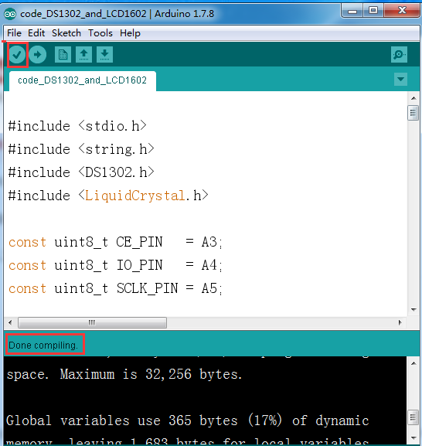

1. In the menu bar of Arduino IDE，you need to select the 【Tools】---【Port】--- select the port that the serial number displayed by the device manager just now.for example:COM6,as shown in the following figure.

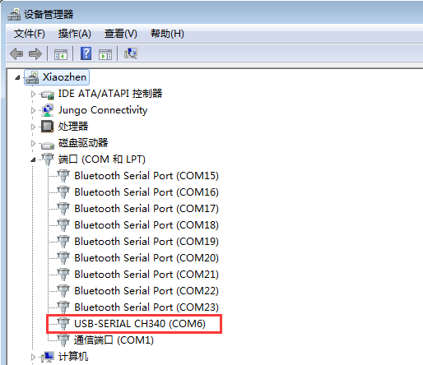

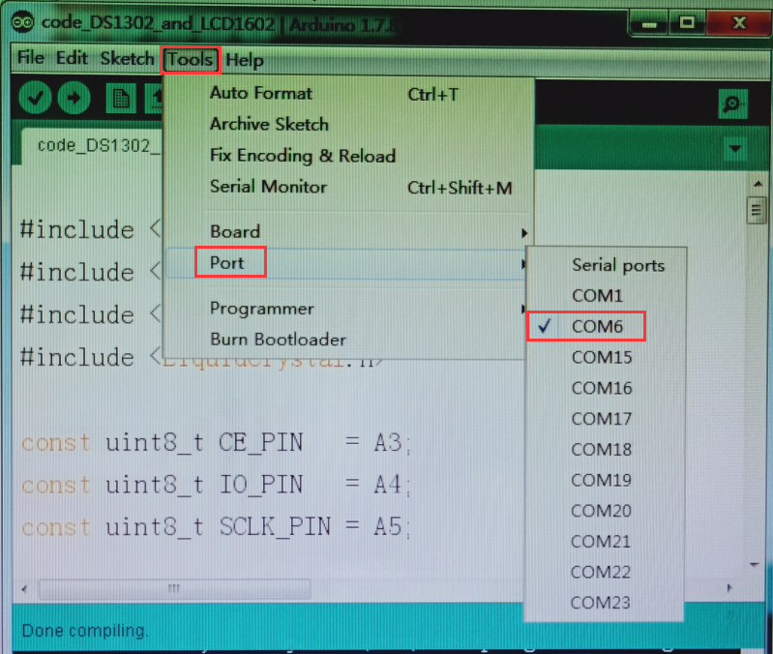

1. After the selection is completed, you need to click “**→**”under the menu bar,and upload the program to the Arduino UNO board, when appears to **Done uploading** on the lower left corner , that means that the program has been successfully uploaded to the Arduino UNO board, as shown in the following figure.

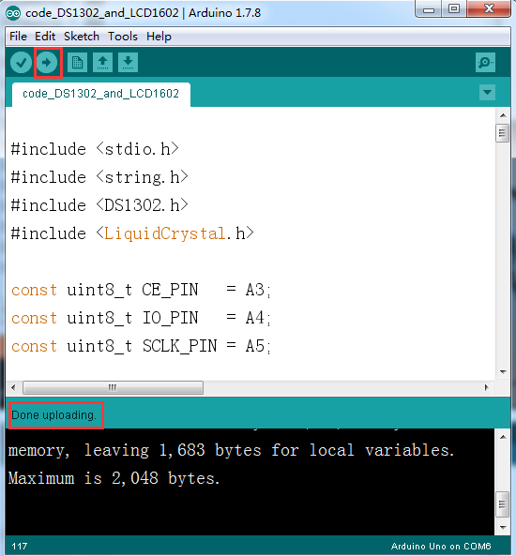

1. We can see the current date and time on the LCD 1602, as shown in the following figure.

(Note: If the LCD 1602 cannot be displayed, you can adjust the contrast by turning the adjustable resistor. The 1602 will display normally)

